Princess Sumaya University for Technology

King Abdullah II Faculty of Engineering

Electrical Engineering Department



|  |
| --- |
| **SMART HOME FOR DEAF PEOPLE** |

**DONE BY: Supervisors:**

**Eman Qaisieh 20190293 Dr. Belal Sababha**

**Aye Taha 20190584 Eng. Abdulghani Al-Jundi.**

**Huda altaie 20190929**

**Table Of Contents:**

Abstract…………………….…...……………………………..……..3

Introduction And Background …………………………...……..……3

Mechanical Design.…………………………………………………..4

Electrical Design.…………………………………………………….4

Problems And Solutions………………………………...……..……..4

Software Diagram …………..………………………………………..5

Final Results…….…………..………………………………………..5

Conclusion ……...…………..………………………………………..5

References ………...………..………………………………………..5

**Abstract**

This report documents the design and implementation of a smart home for deaf people using a PIC16f877A microcontroller and DC Motor. The PIC16f877a is programmed to turn different colors of lights according to the event .The DC Motor is used to open the doors if there is a fire inside the house. . The report includes information on the circuit design, programming, and testing of the smart home, as well as any challenges that were encountered and overcome during the development process.

**Introduction**

The smart home for deaf people is system that will display the events in lights instead of sound for deaf people. This documentation report will provide an overview of the hardware and software components used to build this system using the PIC16F877A microcontroller, DC motor ,Relays, temperature sensor, flame sensor, LCD Display. The PIC16F877A will be used to show the room temperature on the LCD Display and if it is more than a certain temperature or there is a flame, red lights will turn on and the door will automatically open using a DC motor. Also, if the bell rang green lights will turn on with “DOOR BELL “sentence on the LCD Display

**Background**

Traditional fire alarm systems rely on auditory alarms, which can be problematic for people who are deaf. The PIC 16F877A microcontroller, green and red LEDs, a DC motor with an H-Bridge, and temperature and flame sensors have all been designed as part of a fire alarm system to address this. This device offers tactile feedback via the DC motor, visual indications via LEDs, and accurate detection with temperature and flame sensors. By providing a comprehensive solution that is specifically suited to their specific requirements, it assures the protection of deaf people during fire situations.

**Mechanical design**

* Tools used for the project.
* Dc motor
* Relay Module 5V DC
* LED Strip
* LCD
* L298N Dual H-Bridge
* Flame sensor FC-01-H
* LM35 Temperature sensor

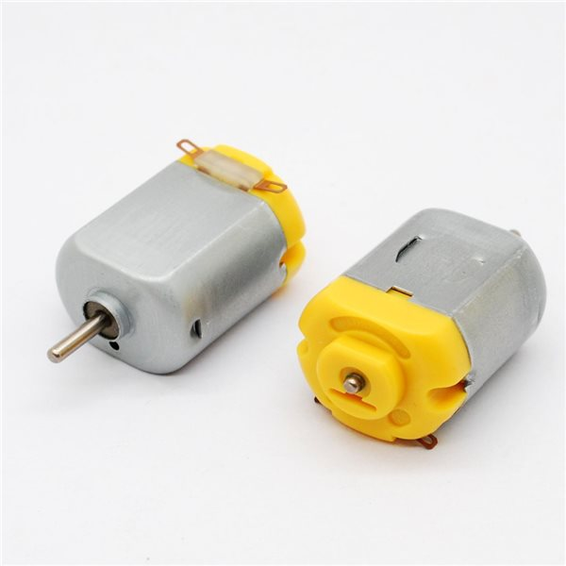

* DC MOTOR
* Name:130 motor
* Axial length:8mm
* Diameter of axle:2mm
* Specification:20*15*25mm
* Rated voltage: 3V
* No-load speed: 8000 r / min (max)
* Load current: 100mA
* Stall Current: 0.7A
* Weight: 17 grams

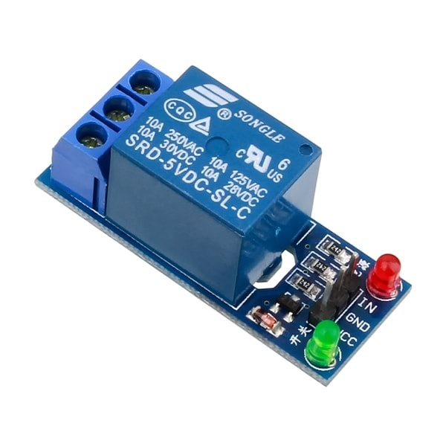

* RELAY MODULE 5V DC 1-CHANNEL
* Description:
* This is 1-Channel DC 5V low level Relay Module.
* Equiped with power relay 10AAC 250V/125VDC 30V/28V.
* Features:
* Product Name Relay Module
* Relay Type SRD-05VDC-SL-C
* Material MetalPlasticElectric Parts
* Coil DC 5V
* Load 10AAC 250V/125VDC 30V/28V
* Overall Size 42 x 17 x 15mm/ 1.6" x 0.7" x 0.6"(L*W*H)
* Main Color Blue
* Weight 15g

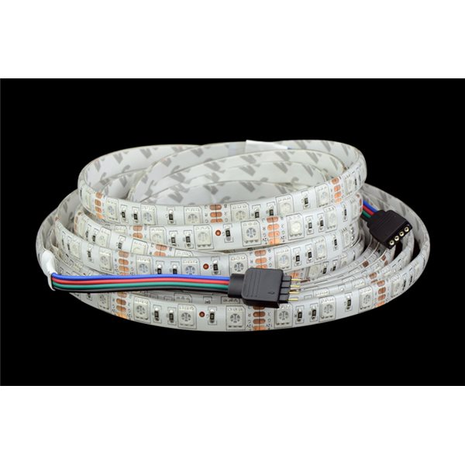

LED STRIP

* Description:
* Superb right 5050 SMD LED, high intensity and reliability.
* Long life span 50,000 hours
* Continuous length, packed with 5 meter.
* Flexible ribbon for curving around bends
* 5.Completely smooth and even light spread, solving the uneven luminous problem
* 6.Ultra-bright but running at low temperature
* 7.Low power consumption
* Features:
* 1.Size: L500cm (5M) x W1cm x T0.35cm
* 2.Emit Color: white / warm white / blue / green / red / RGB
* 3.Protection Rate : IP65 / IP20
* 4.Working Voltage: 12V DC
* 5.LED Quantity: 60leds / 1meter, 300leds / 5meter
* 6.View angle: 120 ° ~ 140 °
* 7.Working Temperature: -20 ° to 50 °

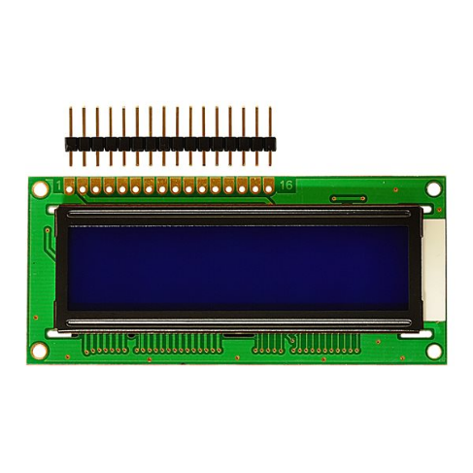

LCD

* The standard 16X2 LCD character module (backlit / blue screen)
* 1602 using a standard 16-pin interface including:
* 1 foot: VSS ground power
* 2 feet: VDD of 5V positive power
* Pin 3: V0 LCD display contrast adjustment end connected to the positive power supply contrast weakest grounded power highest contrast the contrast is too high will produce"ghosting" by using a 10K potentiometer to adjust the contrast
* 4-pin: RS register select the data register select high and low select the instruction register.
* Pin 5: R / W for read and write signal line a high read operation write operation is low. When the RS and RW can write low instruction or display address when RS is high whenthe low RW can read busy signal when RS is high RW can write low data.
* : E end of the first 6 feet to enable end When E Duanyou high jump goes low the LCD module execute command.
* 7 to 14 feet: D0 ~ D7 8-bit bi-directional data line.
* 15 feet: backlight power supply positive
* 16 feet: backlit negative supply

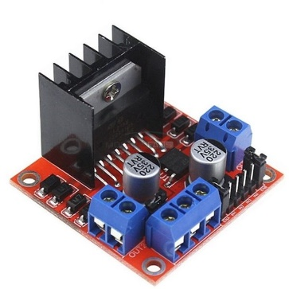

Double H bridge drive

* Chip L298N (ST NEW)
* Logical voltage 5V
* Drive voltage 5V-35V
* Logic current 0mA-36mA
* Drive current 2A (MAX single bridge)
* Storage temperature -20 to +135
* Max power 25W
* Weight 30g
* Small size 43*43*27mm ( approx 1.75" x 1.75" x 1")
* Compatible with L297/L298 driver

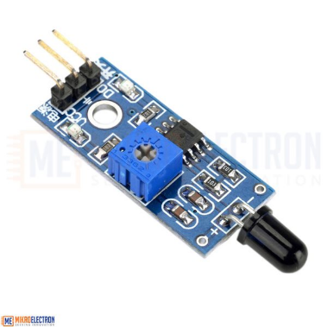

* FLAME FIRELIGHT SENSOR MODULE
* Description:
* Model FC-01-H
* Quantity 1
* Color Blue
* Material PCB
* Features:
* Sensitivity is adjustableWide voltage
* LM393 Comparator outputwith clear
* signal and good waveformDigital switch output: 0 / 1

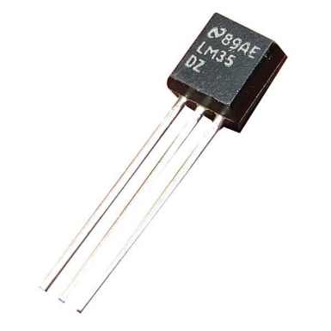

LM35 TEMPERATURE SENSOR

* The LM35 Temperature Sensor is an integrated circuit-based sensor that generates an analog voltage proportional to the temperature of the immediate surrounding area. It is commonly available in a TO-92 package just like a typical small-signal transistor.
* Specificallythe LM35 outputs a voltage that is proportional to the temperature in degrees Celsius with 10 millivolts/°C. Sofor exampleif output voltage is 300mVthe ambient temperature is 30°C. If output voltage is 500mVambient temperature is 50°Cand so on. The sensor output is guaranteed to be accurate within 0.5° of the actual temperature.
* The LM35 temperature sensor does not require any external calibration or trimming. The LM35C is rated to operate at -40°C to +100 °C and the LM35D at 0°C to 100°C

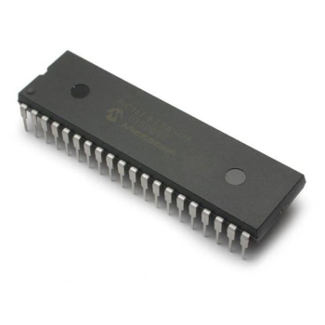

PIC16F877A

* Description: Microchip\'s 16F877A 8-Bit Processor. 8K of program space and 33 I/O lines8 of which are 10bit Analog to Digital converter capable. Runs up to 20MHz with external crystal. Package can be programmed in circuit**.**

**Electrical Design**

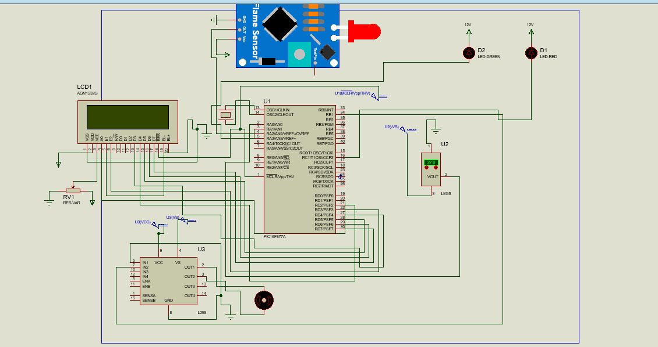

**Problems and solutions**

During our project, we encountered a couple of significant challenges that required innovative solutions. Firstly, we faced difficulties in controlling the LEDs as they were not responding to the signals we were sending. After troubleshooting, we realized that the LEDs required a higher voltage than our microcontroller could provide. To overcome this hurdle, we implemented a relay system that acted as a switch, allowing the microcontroller to control the LEDs indirectly by activating the relay. This solution effectively resolved the LED control issue.

Secondly, we experienced repeated failures with the microcontroller, which would consistently burn out and become inoperable. By employing these creative solutions, we overcame the challenges we faced during the project. These experiences taught us the importance of thorough troubleshooting, adaptability, and the need to implement protective measures to prevent future mishaps. Despite the initial setbacks, our team's determination and problem-solving skills allowed us to complete the project successfully**.**

**Software Diagram**

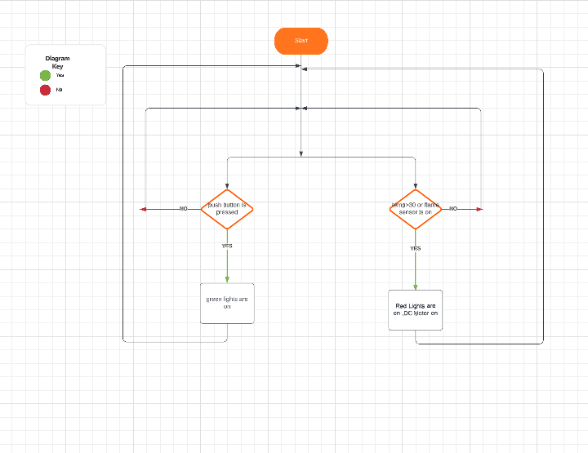

**Final result**

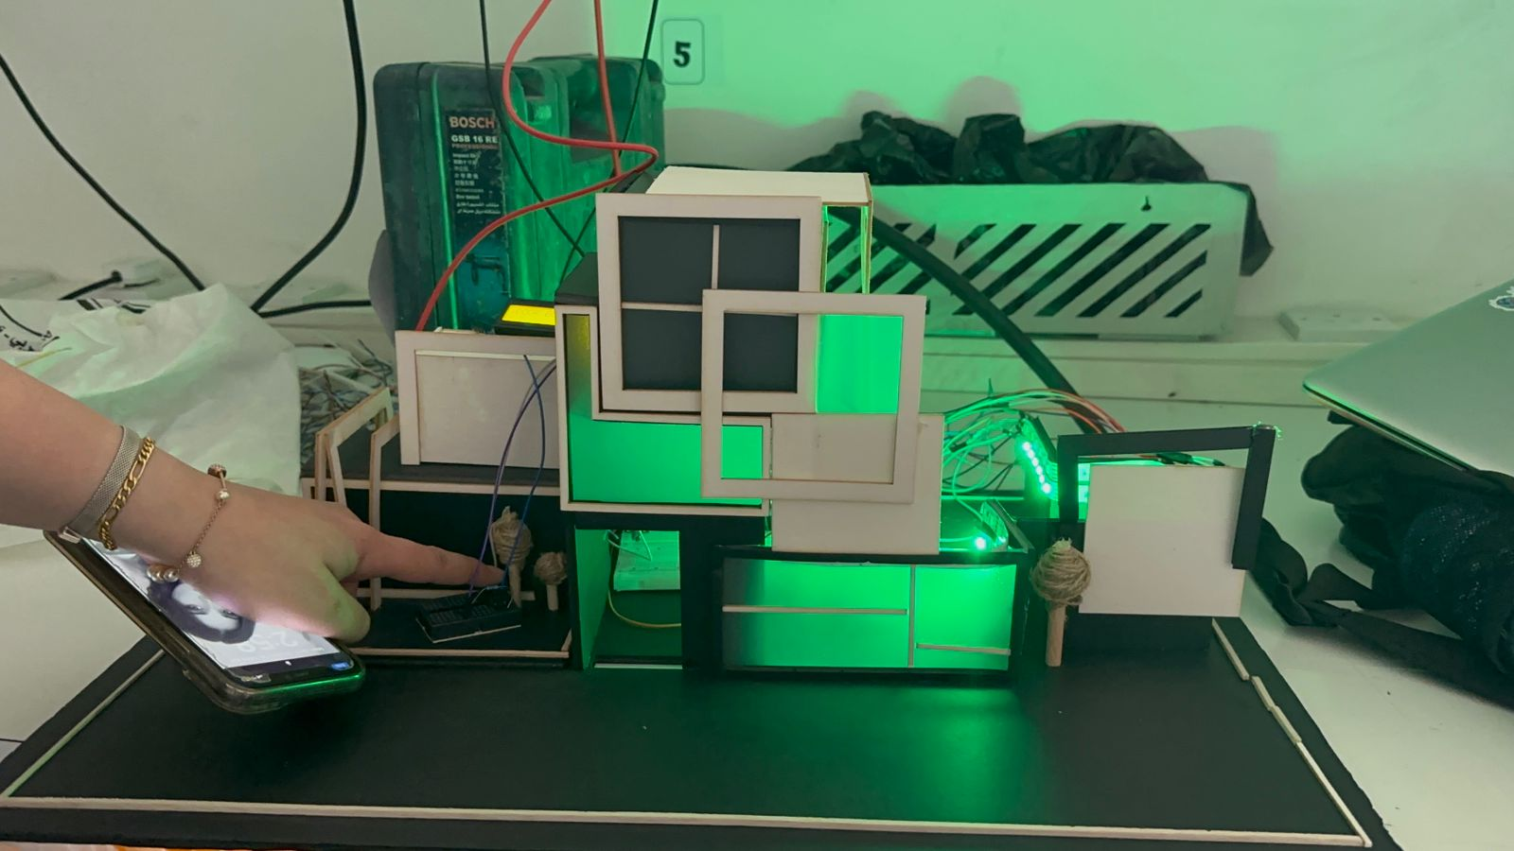

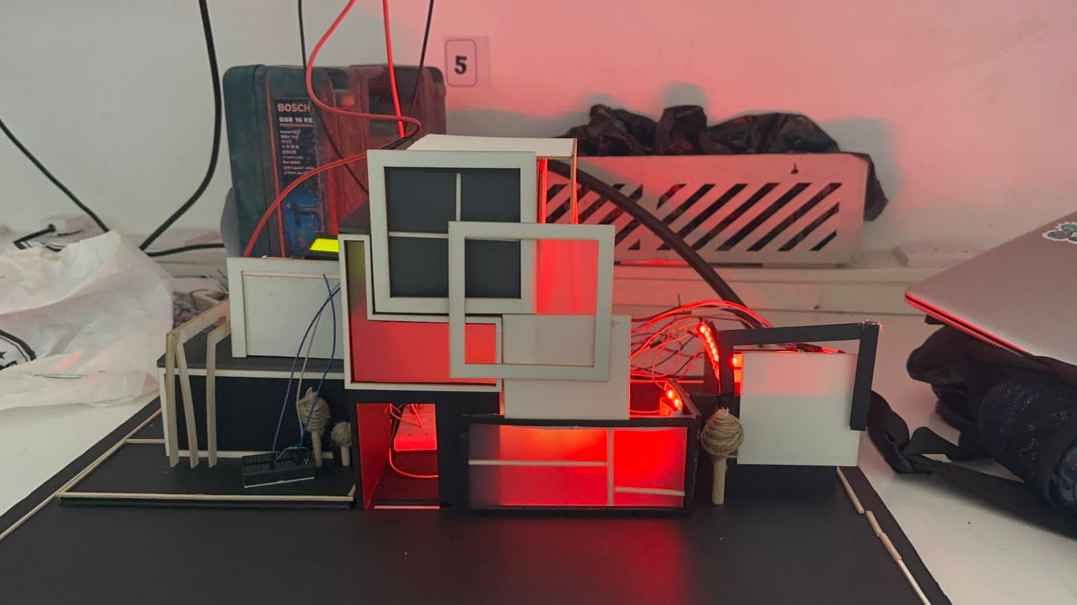

**Conclusion**

In conclusion, our project focused on developing a smart home system specifically designed for deaf individuals, utilizing the 16F877A PIC microcontroller. Throughout the project, we implemented several key components and designs to enhance accessibility and convenience for the deaf community.